Programming Project 1: Uninformed Search
- Your name and CSM Campus Wide ID (CWID).
Name: Ping Zhang
CWID: 10909957
- What programming language and its version are used for developing your source codes?
Programming language: Python
Python version: Python 3.6
- What OS and its version are used to compile and run the codes?
OS version: Window 11
- How the code is structured.
There are 4 functions in my code as below:
parse_input(filename):
return city_neighbors

uninformed_search(origin_city, destination_city, city_neighbors):
return city_expanded

traceback_route(origin_city,destination_city,city_expanded,city_neighbors):
Return route,distance

main():
Command argv: file_name, origin_city, destination_city
Output format:
distance:
route:
Bremen to Hamburg, 116.0 km
Hamburg to Luebeck, 63.0 km
(2)
(3)
(4)..
- main( )：Parse Command argv: file_name, origin_city, destination_city
- parse_input(filename): Using a dictionary data structure named city_neighbors to store all the neighbors for each city. The key point is each city is the key of the dictionary, and the value of the dictionary is a data structure, which key is the city neighbor and the value is the cost between the two cities. The return of this function is a dictionary as below:
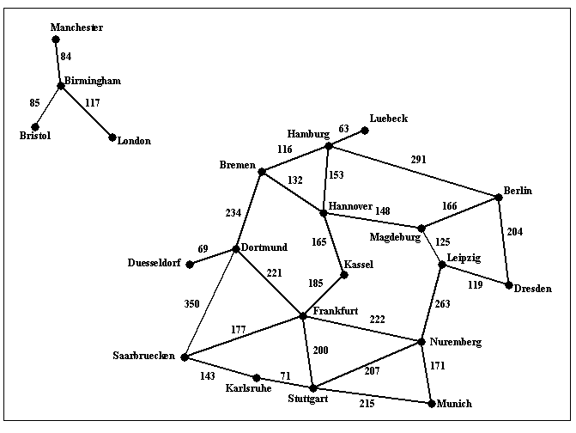
Dictionary: Key
City neighbor 2

City 1
City neighbor 1
City neighbor 3

...... ......
Dictionary: Value
Dictionary: Key
(city neighbor)

Dictionary: Value
(the cost between the two cities)

Cost value 1
City neighbor n

Cost value 2
Cost value 3
Cost value n
- uninformed_search(origin_city, destination_city, city_neighbors): Using dictionary data structure to build the tree search framework named city_expanded. There are several steps in this procedure.
- Using Priority Queue pop the smallest value（the smallest path cost）in the queue.
- Using a dictionary data structure named city_expanded to build the search by loops of the key of the city_neighbors.
- Updating the cost value in the search path, and putting the path cost value into the Priority Queue.
- Do the steps above by a while loop until the Priority Queue is empty.
- traceback_route(origin_city,destination_city,city_expanded,city_neighbors): Trace backing the search tree to find the shortest path from the origin_city to destination_city by a while loop in city_expanded and city_neighbors. The return of this function is the distance value and list of cities that build the shortest path.
- How to run the code, including very specific compilation instructions, if compilation is needed. Instructions such as "compile using g++" are NOT considered specific.
Environment : Window 11 + Window 11 + Python 3.6
Compilation ：No Need
There are three steps for execute the code:
- Step 1: locate to the project folder path
For Example: cd C:\Users\41339\OneDrive\Desktop\CSCI404\project
- Step 2: locate to the Python.exe path
For Example: C:\Software\Anaconda3\envs\python36\python.exe
- Step 3: type the requested command
For Example: find_route.py input1.txt Bremen Luebeck

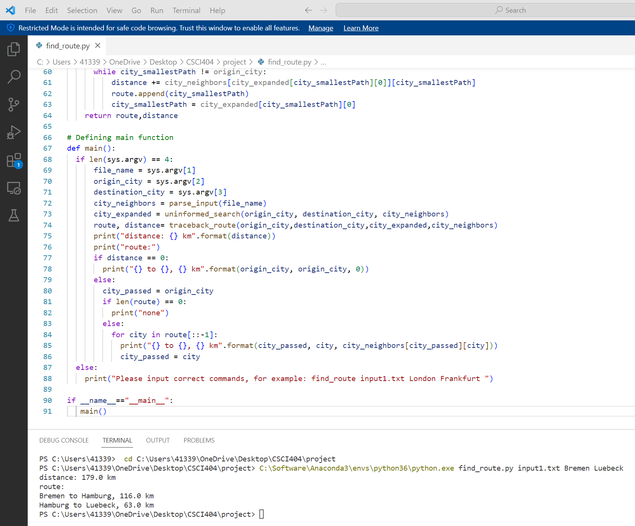
Step 1
Step 2
Step 3
Programming Project 1: Uninformed Search
Design two sets of test cases as described below.
- 10 points: 5 test cases designed for using the provided map.
- 10 points: a new map file (visualization like the above figure is not required) and 5 test cases designed for using the new map.
A: 10 points: 5 test cases designed for using the provided map.
- find_route.py input1.txt Bremen Luebeck
- find_route.py input1.txt Bremen Berlin
- find_route.py input1.txt Hannover Munich
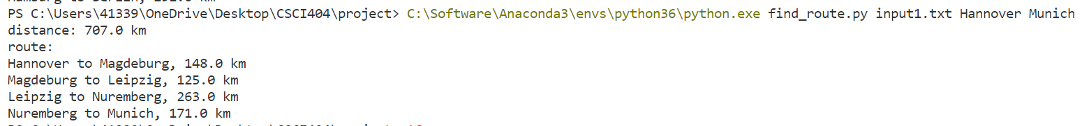
- find_route.py input1.txt Birmingham Duesseldorf
- find_route.py input1.txt Karlsruhe Hamburg
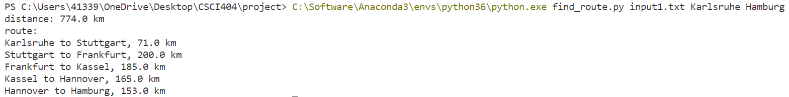

B：10 points: a new map file (visualization like the above figure is not required) and 5 test cases designed for using the new map.
Boulder
Superior
Lafayette
Louisville
Broomfield e
Northglenn e
Thorntone
Denver
Aurora
Littleton
Glendale
Lakewood

Arvada

Golden
Westminster
12
11
7
51
41
101
9
9
13
8
6
9
7
8
7
50
7
8
10
4
13
12
10
9
10
12
- find_route.py a.txt Boulder Golden
- find_route.py a.txt Superior Denver

- find_route.py a.txt Lafayette Littleton
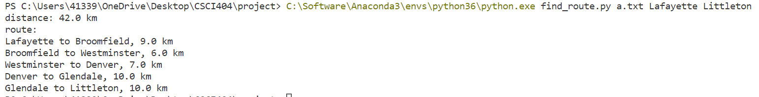

- find_route.py a.txt Golden Aurora
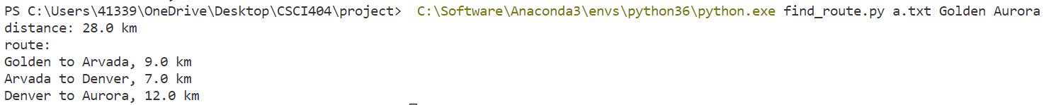
- find_route.py a.txt Arvada Thornton

